# **Technical SEO Audit**

# Findability Checks

# This section will cover how accessible your website’s content is to external bots and internal users.

### **Indexation Status**

### **Server Uptime**

### **Robots.txt check**

### **Use of Meta Robots Tag**

### **Client Side (40x) Errors**

### **Client Side (50x) Errors**

### **HTML Sitemap Check**

### **XML Sitemap Check**

### **Video XML Sitemap Check**

### **Image XML Sitemap Check**

### **Use of Pagination**

### **Check for Custom 404 Page**

### **Check for Subdomains**

## What is indexation? Why does indexation matter?

How many pages on your website are indexed by search engines. If you have a lot of content on your website, this will tell you if Google is aware of it.

A low indexation rate could point to a number of issues (lack of internal linking, render blocking code on your pages, low domain authority and more).

### **How can I check my site’s index rate?**

1. By going to Google and typing in ****site:yoursite.com**** and seeing how many pages show up in Google’s index.

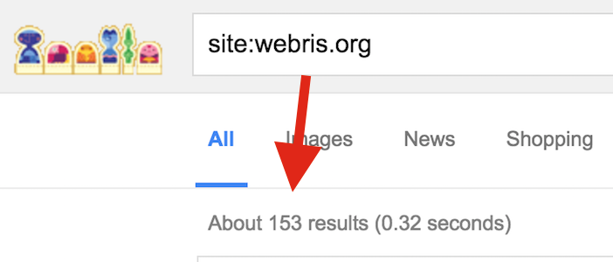

2. By checking your [Google Search Console](https://www.google.com/webmasters/tools/home?hl=en" \t "https://webris.org/technical-seo-audit/_blank) to see how many pages are indexed.

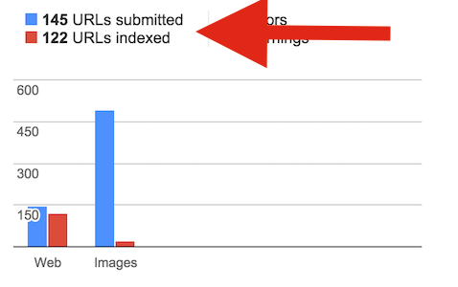

### **What is server uptime? Why does website uptime matter?**

The ability for your hosting and web server to keep your website online and reduce downtime.

Website speed and stability are crucial for search engines to index your website regularly and properly.

### **How can I check my site’s uptime?**

1. You can run a free check using [Pingdom](https://www.pingdom.com/" \t "https://webris.org/technical-seo-audit/_blank).

2. Also you can check on Google Page Insight & Webpage test

3. For large website, ****monitoring is a must****. If you experience issues with website uptime, upgrade your hosting to a private server or dedicated package.

#### **3. [What is a Robots.txt file](https://webris.org/wiki/robots-txt/" \t "https://webris.org/technical-seo-audit/_blank)?**

This file instructs search engines on how to access your website.

#### **How can I check my site’s Robots.txt file?**

* Visit yoursite.com/robots.txt (it’s publicly accessibly on the web)
* In [Google Search Console](https://www.google.com/webmasters/tools/home?hl=en" \t "https://webris.org/technical-seo-audit/_blank), navigate to Crawl > Robots.txt tester

#### **What is a meta robots tag**

This HTML tag is placed in between the <head> code on a page and gives search engines instructions on how to interpret that page specific content (NOT site wide).

For example, <meta name=”robots” content=”noindex”> lets search engines know **not** to index that page.

## ****NOTE****: Don’t confuse this NOFOLLOW with the rel=”nofollow” link attribute. A “nofollow” in the <head> section will ****no follow all links on that page****, while the rel=”nofollow” is link specific.

#### **Why do meta robots tags matter?**

Sloppy web development could have accidentally placed “noindex” directives on important, which would cause your site to have a low index rate.

#### **How can I check my site’s meta robots tags?**

* Dump your URL into Screaming Frog SEO Spider.
* Under the “Internal” tab, scroll to the right.
* You will see “Meta Robots 1” and “Meta Robots 2”.
* These two columns will tell you the directives of each page on your website.

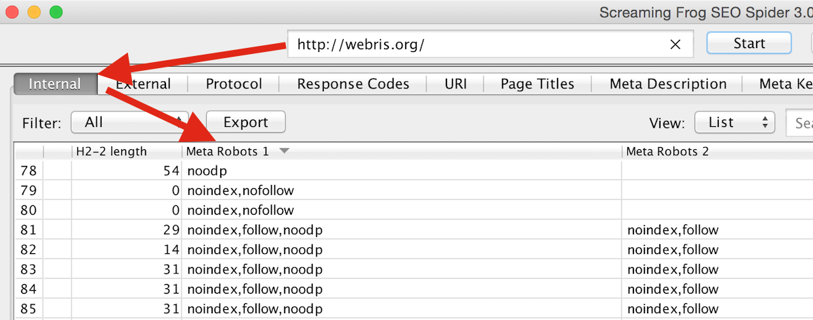

#### **What 40x errors?**

* 40x are “Bad Request” errors take place when the request sent to the web server, fails.
* There are a number of client side errors that can occur (401, 403) but the most common is a 404 error, which generally happens when traffic is directed to a page that no longer exists.

#### **Why do 40x errors matter?**

* General rule of thumb, anytime your website isn’t rendering properly for visitors, this is a bad thing
* 404 errors in particular go against SEO best practices. When deleting or moving pages, we want to make sure the proper steps have been taken to ensure a proper user experience (UX) and minimal loss of inbound link equity
* 404 pages with inbound links or [significant inbound traffic](https://webris.org/get-more-organic-traffic-right-now/) should be 301 (permanently redirected) to a similar piece of content on your site.

#### **How can I check my site’s 40x errors?**

* Log into your Google Search Console.
* Navigate to Crawl > Crawl Errors.
* You will see a list of 4ox errors occurring on your site.
* Are these pages you meant to delete? Do they have inbound links pointing to them? Traffic? Consider setting up 301 redirects to manage them.

#### **What 50x errors?**

When failure to render a page falls on the server.

#### **Why do 50x errors matter?**

A large spike in these errors could point to an inability for your web hosting and server to manage the requirements of your website, resulting in downtime for visitors.

#### **How can I check my site’s 50x errors?**

* Log into your Google Search Console.
* Navigate to Crawl > Crawl Errors > Other.
* You will see a list of 5ox errors occurring on your site (if applicable).

**To know more about 40x and 50x error** :- [https://en.wikipedia.org/wiki/List\_of\_HTTP\_status\_codes#5xx\_Server\_Error](https://en.wikipedia.org/wiki/List_of_HTTP_status_codes" \l "5xx_Server_Error)

#### **What is an HTML sitemap? What is an XML sitemap?**

A **sitemap** that lives on a web page, not an XML file.

An **XML file** that helps search engines better crawl and understand your website.

A **video sitemap** helps search engines to quickly identify video content and index it for video searches.

An **image sitemap** helps search engines to quickly identify image content and index it in image searches.

#### **Why do HTML sitemaps matter?**

* HTML sitemaps provide an easily navigable view for website users.
* In addition, they provide a page that can evenly distribute equity to deep and less crawled pages on your website.
* If you create video content, a video sitemap will help you rank in Google Videos section. This is a great way to easily boost organic traffic.
* Getting your images ranked for image based searches can skyrocket organic traffic

#### **Why do XML sitemaps matter?**

* They help improve indexation of your website.
* You’re able to set a “crawl budget”, i.e. the importance of each page / page type on your website. This is especially important for massive (10K+ pages) websites that want to give preference to set of pages for search engine crawl time.
* It helps protect your website against duplicate content. Getting a page indexed and list in your sitemap will give you ownership over it.

#### **How can I check if my site has an HTML sitemap and XML sitemap**

* Do you have a page on your website that links to every page on your site?
* [Use this tool to generate an HTML sitemap](https://www.xml-sitemaps.com/" \t "https://webris.org/technical-seo-audit/_blank).

TO check XMl sitemap

* Visit yoursite.com/sitemap.xml – do you have one listed?
* In Google Search Console, navigate to Crawl > Sitemaps.
* For non WordPress sites, [use this tool](https://code.google.com/p/sitemap-generators/wiki/SitemapGenerators" \t "https://webris.org/technical-seo-audit/_blank).

For Video Sitemap

* Visit yoursite.com/sitemap\_video.xml – do you have one listed?
* In Google Search Console, navigate to Crawl > Sitemaps.
* [Use this tool to generate a video sitemap.](https://code.google.com/p/sitemap-generators/wiki/SitemapGenerators" \t "https://webris.org/technical-seo-audit/_blank)
* Submit your video sitemap in Google Search Console, (Crawl > Sitemaps > Add/Test Sitemap).

#### **What is pagination?**

HTML commands (“rel = prev” and “rel = next”) on content that spills over into multiple pages, but should be treated as one. Pagination tags should be used on the “Next page” and “Previous page” links to alert search engines of this. This also applies to eCommerce sites with multiple product pages and long guides that is broken down into multiple pages.

#### **Why does pagination matter?**

These tags can help combat duplicate content penalties and low indexation rates.

# Architecture Checks

The structure of your website is incredibly important for search engines to properly rank it. This section covers the necessary checks to ensure it’s setup properly.

### **Check for Breadcrumbs**

### **Top Level Navigation (TLN) Analysis**

### **Footer Analysis**

### **Site Depth Check**

#### **What are breadcrumbs?**

A trail, or secondary navigation, clearly visible to website users to help them navigate your website.

#### **Why do breadcrumbs matter?**

* Search engines crawl from page to page through links. Breadcrumbs enforce page hierarchy and navigation to search engines. If you have a content heavy website, users can get lost deep in your site. Breadcrumbs help to easily find their place and continue browsing, without having to use the top level navigation to return.
* This check is better for eCommerce sites, less important for smaller sites with low pages.

#### **What is a TLN? Why do TLNs Matters**

* The main menu and navigation on a website.
* Users want a logical, easy to use and find menu that clearly directs them where they need to go.
* Search engines want the same thing – your top pages should be linked to from the TLN, whether that’s a dedicated section or a drop down depends on the amount of content on your website.

#### **How can I analyze my site’s TLN?**

* Are your target pages linked to from your TLN?
* Are you using SEO optimized titles in your TLN?
* Is your TLN well organized for user’s to find what they need with minimal clicks?
* **Your TLN should be coded in HTML, NOT JS!**

#### **How can I analyze my site’s footer?**

* It really depends on your website’s goals, niche and depth of pages.
* Generally speaking, I like to use the footer to link to important, non sales pages.
* Google’s latest update looks hard at the quality and depth of content on your website to ensure that you’re a legitimate, functioning business.
* FAQ, locations page, privacy policy, careers, HTML sitemap and other pages important pages that search engines look for to determine the quality of your website.
* It’s important to get these pages crawled by search engines, the footer is the best place to show search engines that these pages are an important part of your website.
* You can’t link to every page on your website from your TLN (unless you have a small website).
* Footers provide a great opportunity to pass equity to various pages or sections on your website.

#### **What is site depth / structure?**

This refers to the number of ‘clicks’ your pages are away from the starting URL.

#### **Why does site depth / structure matter?**

* Both search engines and users shouldn’t have to click 1,000 times to get to important content on your website.
* General SEO best practices state to keep important contnet (i.e. pages you want to rank) within 4 click of the starting URL (i.e. your home page).
* Basically what that means is target pages should be easily accessible from top level nav, footer or located within a few clicks of these pages.

#### **How can I analyze site depth / structure?**

* In Screaming Frog, run a crawl of your website.
* All the way to the right, click on “Site Structure”.
* You will see stats about how many pages you have and their depth from the starting URL.
* Analyze which pages are over 3 clicks and decide if there’s a better place for them to live within your website.

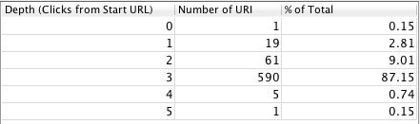

# URL Analysis

This section is dedicated entirely to analyzing a website’s URLs for proper optimization. The entire analysis will be done using Screaming Frog SEO Spider for analysis.

### **URL Delimiter Check**

### **URL Friendliness**

### **Absolute vs. Relative URLs**

#### **(URL Delimiter Check) What are hyphens in the URL?**

**The default URL structure should use hyphens (” – “). For example:**

****Good****: http://yoursite.com/miami-seo-professionals/

****Bad****: http://yoursite.com/miami\_seo\_professionals/

****Worse****: http://yoursite.com/miami,seo,professionals/

Using \_ or , as your URL structure causes search engines to read URL strings wrong.

**NOTE:- Search engines read – as spaces. Using them ensures your content will be read the right way.**

#### **How can I check my URLs?**

* In Screaming Frog, run a crawl of your website.
* Set the tab to “URI”.
* In the search bar, enter “\_”.
* Filter the results to see if your URLs contain underscores.

NOTE: you can also export your crawl to Excel for better filtering and analysis.

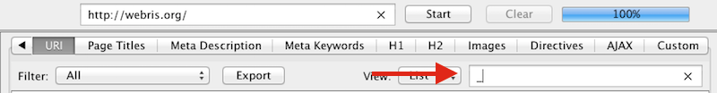

#### **What is URL friendliness?**

* URLs should be structured (when possible) to be clean, short, memorable and shareable.

**For example, which would you click?**

* http://site.com/cute/10-cutest-puppies-ever/--------Good
* http://site.com/9dfshre/?324323/10sfd-fscutest-pfdsuppies-sdfever/------------Bad

#### **How can I check my URLs?**

* In Screaming Frog, run a crawl of your website.
* Set the tab to “URI”.
* Export data to Excel and analyze.

#### **What are absolute and relative URLs?**

* Relative URLs are often used by web developers as shorthand to code internal links on a website. They do not contain the full URL, but still link to the destination page.
* Absolute URLs contain the full URL string when linking internally to another page.

#### **Why does this matter?**

* Relative URLs are SLIGHTLY better for page loading times and easier for developers when coding HTML.
* Absolute URLs are better for SEO as they contain the full URL string, better optimized for search engine crawling.

#### **How can I check my URLs?**

* On any given page on the website, right click and select “view source code”.
* Find an internal link.
* If it’s coded as <a href = “http://yoursite.com/link/” > anchor</a>, it’s an absolute link.

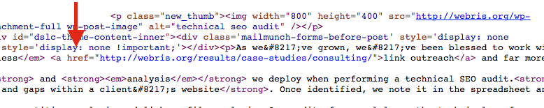

# “On Page SEO” Checks

This is the biggest section on the audit. It covers how to analyze individual pages in bulk to uncover issues with the site.

### **Meta 'hreflang' (used SF signal: 'hreflang=')**

### **Authorship markup (rel='author' or rel='me')**

### **Publisher markup**

### **Page Source META tag**

### **Visible <title> tags per page**

### **Page headings (H1)**

### **Use of structured data markup (Schema.org)**

### **Key Content Location**

### **Editorial Strength**

### **Pages With Thin Content**

### **Image Location**

### **Image Sizes**

### **Use of Image ALT Tags**

### **Missing <title>**

### **Duplicate <title> Tags**

### **Title Tag Length**

### **Missing Meta Descriptions**

### **Duplicate Meta Descriptions**

#### **What is Meta “hreflang”?**

Signals to Google which language is being used on a page. If you have content in different languages on your website, you want to make sure that the appropriate page is served to the searcher based on what language they’re using.

#### **How can I check for Meta “hreflang” on my site?**

* Right click + “View Page Source”.
* Search HTML for reflang markup (<link rel=”alternate” href=”example.com” hreflang=”es-es” />)

#### **What is Publisher markup**

This markup connects the entire website to the publisher

* This markup connects the entire website to the publisher.
* While they can be used mutually exclusive, publisher markup is for companies and authorship markup is for individuals.
* Similar to how authorship markup shows a picture of the author as a rich snippet, publisher markup shows a summary of the companies google plus page on the right hand side of the screen when someone searches for the company by name.

#### **Why does Publisher markup matter?**

* It good for branding as the searcher will get a snapshot of your company’s name, logo, address, pictures and reviews.

#### **How can I check if I have Publisher markup?**

* Verify that your website is connected to your business google plus page.
* Check the <head> section of your website for this code <link rel=”publisher” href=”page url”

#### **What is Page Source Meta tags?**

The information that is displayed by the search engines in the SERPs about a particular page or website. Your meta descriptions should be no longer than 156 characters. Anything more will get truncated by Google.

#### **How can I check if I have Meta Tags**

* You can view the source code of your page and look for <title> <description> in the head tag.
* Check your Screaming Frog report.

#### **What are <title> tags?**

The title of your pages. This should be written both for SEO benefit and to incite a click from the user. It’s best to structure your page title with your main keywords within in. You must keep page title’s to under 65 characters. Anything more will get truncated by Google.

#### **Why do the <title> tags matter?**

* Title tags are HUGE on page ranking factors.
* It draws the most attention to the user in the SERP with larger text and highlighted blue.

#### **How can I check my <title> tags**

* Viewing the source code of your page.
* Using the site:url operator to read your titles in SERPs.
* Check your Screaming Frog audit.

#### **What are page headings?**

Aka <h1> tags, are generally found at the top of the page and display the page’s heading (may be different from the title tag). There should only be 1 heading on each page.

#### **Why do H1 tags matter?**

Tells search engines about important content on the page. A good place to work in LSI keywords different from the main keyword in the title tag.

#### **How can I check my H1 tags?**

Check your Screaming Frog Audit.

#### **What is structured data markup**

A snippet of code (HTML) located in the <header> tag that instructs search engines what your page is about.

These markups come in different forms (local business, video, etc) and should be used based on your website and content type.

#### **Why does structured data markup matter?**

* It makes it easier for Googlebot to get to the meat of what your page is about without having to read complex code.
* For product reviews, having a rich snippet show up on the SERP with stars, which greatly increases click through rate.

#### **How can I check for structured data markup?**

Paste your website’s URL into [Google’s Structured Data Testing Tool](https://developers.google.com/structured-data/testing-tool/" \t "https://webris.org/technical-seo-audit/_blank).

#### **What is key content location**

The place where important, topical related content appears on the page.

#### **Why does key content location matter?**

* Search engines read content from top to bottom. Topically related content should be mentioned near the top of the page to give the page the most relevancy for the desired topic.
* Your main keyword should be in the h1 tag and LSI variations of keyword should be placed in h2, h3 (when appropriate) without overtly keyword stuffing.

#### **How can I check the key content location?**

* Right click + “view page source” and search the h1, h2 and h3 tags
* Use the “find” feature on a webpage to view the location of keywords on the page.

#### **What is editorial strength**

* The quality of the content being published (length, authoritative, informative).
* Determine if the content is compelling enough for [link building efforts](https://webris.org/link-building-strategies-that-work/).

#### **Why does editorial strength matter?**

* Content that is well written, robust and properly optimized will index quicker and rank better in search.
* Conversely, thin content, duplicate content or keyword stuffed content will not rank well and runs the risk of penalty and/or deindexing.

#### **How can I check the editorial strength of my content?**

* Use Grammarly to check for grammar errors.
* Use a free online word counter tool to check how many words are in an article and compare that to existing content that’s performing well in the space.
* Use a keyword density checker like [SEO Centr](http://www.seocentro.com/tools/seo/keyword-density.html)o to make sure you’re not over optimizing any keywords.
* If you’ve outsourced content, run it through Copyscape or at the very least, copy and paste an entire paragraph into Google search to make sure it’s not published anywhere else on the net.

#### **What is thin content?**

Pages on a site with very little text and/or without rich media.

Pages that serve little to no value to the end user.

#### **Why does having thin content pages matter?**

* Creates a bad user experience and lower your sites quality score.
* They take longer to index or don’t index at all**.**
* Even if they do index, they have very little value and rank poorly.

#### **How can I check for thin content pages?**

* Open Screaming Frog and enter the domain.
* Scroll over to the right to find “Word Count” and look for pages with less than 300 words (outside of trivial pages ie. contact, about).
* Consider no-indexing these low value pages.

#### **What is image location? Why is image location important?**

Where images on a page are hosted.

Images can be found in search on the web. If someone finds your image you want the path to direct them to your site.

If you’re hosting images on a third party site and that site is terminated, you’ll lose the images on your site.

**How can I find the image location?**

* To check images on a page, hover your cursor over the image. The image url will appear in the lower left hand side of your screen.
* To check images on multiple pages, use Screaming Frog “Images” tab.

#### **What is alt attributes/text?**

When applied to images, the alt text will appear in it’s place when an image fails to render and gives a description of the image.

#### **Why is it important to use alt text?**

* While it’s not recommended to stuff keywords into the alt text, it is place where you can add relevant keywords for SEO purposes.
* Search engines are unable to crawl images therefore unable to determine what the image is or deliver it in search queries without alt text.

#### **How can I check if images have alt text?**

* To check alt text of an individual image, right click on the image and view image info.
* To bulk check alt text, use Screaming Frog “Images” and filter by “Missing Alt Text” to view the images without alt text.

# SEO Equity Tests

### **302 redirects**

### **Check for Redirect Chains**

### **Check for Broken redirects**

### **Check for rel=nofollow Stats**

#### **What is a 302 redirect? Why do 302 redirects matter?**

* Tells search engines that a page has been moved temporarily.
* 302 redirects do not pass SEO equity, meaning if you redirect a page, the link value does not pass through.
* It may prevent content on the new url from indexing because Google believes at some point you will revert back to the redirected url.

**How can I check for 302 redirects?**

* [Screaming Frog](https://www.screamingfrog.co.uk/seo-spider/" \t "https://webris.org/technical-seo-audit/_blank)
* [Redirect Checker](http://www.redirect-checker.org/" \t "https://webris.org/technical-seo-audit/_blank)

#### **What are redirect chains?**

A string of multiple redirects from one location to another.

**Why do redirect chains matter?**

* Having too many redirects may cause the Googlebot to eventually stop following the chain
* You lose “link juice” with each redirect.

#### **How can I check for redirect chains?**

* [Screaming Frog](https://www.screamingfrog.co.uk/seo-spider/" \t "https://webris.org/technical-seo-audit/_blank)

#### **What are broken redirects?**

A link that takes you to an error page.

#### **Why do broken redirects matter?**

* Lead to bad user experience
* Low quality score of your website
* Negatively affect your ranking in the SERPs

#### **How can I check for broken redirects?**

* [Screaming Frog](https://www.screamingfrog.co.uk/seo-spider/" \t "https://webris.org/technical-seo-audit/_blank)
* Google Webmaster Tools > Crawl Errors

#### **What is rel=”no follow”?**

A command telling Googlebot not to pass any equity, trust or credit through a link.

#### **Why do nofollow links matter:**

* If you want to pass link equity through an outbound link or through an internal link on your site
* If you’re link building and getting nofollow links, you’re getting diminished returns on your effort

#### **How can I check for nofollow links:**

* [Majestic](https://majestic.com/)
* [Screaming Frog](https://www.screamingfrog.co.uk/seo-spider/" \t "https://webris.org/technical-seo-audit/_blank)
* [A nofollow browser plugin](https://chrome.google.com/webstore/detail/nofollow/dfogidghaigoomjdeacndafapdijmiid?hl=en" \t "https://webris.org/technical-seo-audit/_blank)

# Google Search Console Audit

### **Google Analytics linked to Google Webmaster**

### **Internal Links**

### **Manual Actions**

### **Page Not Found Errors**

### **Pages Blocked by Robots.txt**

### **Check Pages Indexed**

### **Sitelinks**

### **Sitemap Indexation**

#### **What is Google Analytics?**

A data providing tool by Google to monitor and maintain your site’s performance.

**Why does GA linked to SC matter?**

* Give you data to improve visibility and user experience on your site
* It will inform you of critical issues that have an affect on your site’s rankings
* Give you data that you can use to optimize your website for better conversions

**How can I link Google Analytics to Search Console?**

Sign up for a free account and select one of the methods available to connect your site to Search Console.

#### **What are internal links?**

Links that point to other pages within your website.

#### **Why are internal links important?**

* Internal links pass link equity across your website.
* Establishes a hierarchy within a category ([read more on “silos”](https://webris.org/how-to-create-website-silos-for-seo/)).
* Improves user experience by making it easier to navigate.

#### **How can I check internal links on my site:**

Search Console > Search Traffic > Internal Links

#### **What are manual actions?**

A spam penalty that has been issued to a website by a manual Google review instead of algorithmic penalty.

#### **Why do manual actions matter:**

* Manual actions penalties can negatively affect your site’s rankings.
* You have to request Google to remove the penalty once you’ve addressed the issues by submitting a reconsideration request.
* They can be sitewide or partial – penalties have a major impact on your ability to rank higher in search engines.

#### **How can I check for manual action?**

Search Console > Search Traffic > Manual Actions

#### **What are Page Not Found errors?**

* When a page on your website has been removed or moved and the url in question could not be found on your server.
* A 404 :”page not found error” is shown to the user.

#### **Why are page not found error important?**

You want to be aware of page not found errors so you can address them properly so users are not landing on error pages.

#### **How can I check for Page not found?**

* [Screaming Frog](https://www.screamingfrog.co.uk/seo-spider/" \t "https://webris.org/technical-seo-audit/_blank)
* Search Console > Crawl > Crawl errors

#### **What are Pages Blocked by robots.txt?**

These are pages on your website that the Googlebot is not crawling due to directives in the robots.txt file.

#### **Why do Pages Blocked by Robots.txt matter:**

* At times, you can accidently block the wrong pages from being indexed by search engines.
* Simply removing this directive can mean an instant boost in traffic.

#### **How can I check for pages blocked by Robots.txt?**

Search Console > Google Index > Blocked resources

#### **What are Pages Indexed?**

The number of pages on your website that are in Google’s Index, aka eligible to rank in search results.

#### **Why do Pages Indexed matter:**

* If your pages are not indexed, they will not be found in search.
* Pages not getting indexed is a sign that your site has a penalty or low authority with search engines.

#### **How can I check for Pages Indexed?**

Pages indexed report in GSC.

#### **What are sitelinks?**

Links to pages on your site shown below the meta description in the SERP.

#### **Why do sitelinks matter:**

* Sitelinks have been shown to improve CTR.
* They present your site as a more authoritative resource.
* Takes up more real estate in the SERPs.
* It also allows the user to navigate straight to the pages on your site that are relevant to their search query.

#### **How can I check for sitelinks?**

* Sitelinks are created algorithmically which means there’s nothing you can do to create them.
* You can choose to tell Google not to create a sitelink for a given page by going to Search Console > Search Appearance > Sitelinks

#### **What is Sitemap Indexation?**

The amount of pages on your site that have been indexed.

#### **Why do Sitemap Indexation matter?**

It will tell you if any URLs are not accessible or are blocked by robots.txt.

#### **How can I check my Sitemap Indexation?**

Search Console > Crawl > Sitemaps

# Link Issues

### **Anchor text links**

### **Broken Links (internal 404 broken links)**

### **Check Logo Link**

### **Investigate External Links**

### **Use of No Follow Links**

### **Malicious Links**

#### **What is an Anchor Link?**

A link embedded in text (hyperlink), typically relevant to the content it’s linking to, that can be clicked on.

#### **Why do Anchor text Links matter?**

Anchor text helps Google understand the relevancy and topical nature of the page that it’s linking to.

#### **How can I check the anchor text on my site?**

Screaming Frog Tool using the outbound links tab.

#### **What are Broken Links?**

A standard http response code that indicates the server on which the site is hosted could not find the page requested.

#### **Why do broken links matter?**

* Broken links are natural part of the web however, having too many broken links will give users a bad experience and loss traffic.
* There are better ways to redirect traffic from 404 to relevant, live material.

#### **How can I check for broken links?**

* Screaming Frog
* Broken link checker plugin

#### **What is a logo link?**

A hyperlink in the logo image of the website

#### **What are external links?**

Links that take the user offsite.

Increases the topical relevance of your content.

Helps readers find additional resources not included in your site.

#### **How can I check for external links?**

Screaming from tool external tab.

#### **What is proper use of nofollow?**

* Typically you want to nofollow outbound links.
* Follow links pass credit, trust and link equity which means you’re telling Google you’re vouching for it.
* Having too many follow external link will bleed the juice on your website.

#### **How can I check for nofollow links?**

Screaming Frog tool outlinks tab.

#### **What are malicious backlinks? Why do malicious backlinks matter?**

* Links coming into your site from irrelevant spam sites.
* They can have a direct impact on your seo and cause spam penalties.
* They can shape the topical relevance of your site.

#### **How can I check for malicious backlinks?**

* Search Console > Links to your site
* Majestic

# Google My Business Account?

#### **What is Google My Business?**

Formerly Google+ Pages, it’s your online business center for everything Google.

#### **Why does Google My Business matter?**

* Getting setup and verified as a Google Business is a massive part of SEO for local businesses. Without it, you can’t rank in local search results.
* For larger businesses, it’s also a verified review platform and allows you to get setup in Google Maps.

#### **How can I check if I have a G+?**

Typing in the name, phone and google plus in the Google search bar.

# Social Media Analysis

### **Open Graph Snippet**

### **Twitter Card Snippet**

#### **What is Open Graph Snippet? Why does Open Graph Snippet matter?**

* A meta tag that is used to populate Facebook status box when someone shares your link.
* It allows you to control the image, description and title that Facebook pulls through to the status display when you automate a post or someone shares the link to your page.

#### **How can I check if my Open Graph Snippet?**

* Check the source code.
* Yoast SEO plugin.
* Typing in the meta tags manually.

To know OG Tags :- <https://ogp.me/>

#### **2 What are Twitter Card Snippets?**

Code that you embed into your site that allows an image, title and description of the post to pull through on your tweets.

#### **Why do Twitter Card Snippets matter?**

* They give Twitter users better understanding on the content shared via the link because it shows an image, title and description of the post.
* Help CTR because people see more information.

#### **How can I check for Twitter Cards?**

* Check the source code.
* Yoast SEO plugin.
* Typing in the meta tags manually.

To know more about tags :- <https://dev.to/therealdanvega/how-to-add-twitter-card-meta-tags-to-your-blog-4iei>

**CRASH COURSE** : **19-Step SEO Audit Checklist**

* [Step #1: Check To See If Your Site Is Mobile-Friendly](https://backlinko.com/seo-site-audit" \l "mobilefriendly)
* [Step #2: Make Sure Google Indexes ONE Version of Your Website](https://backlinko.com/seo-site-audit" \l "index)
* [Step #3: Speed Up Your Site](https://backlinko.com/seo-site-audit" \l "speed)
* [Step #4: Find and Delete “Zombie Pages”](https://backlinko.com/seo-site-audit" \l "zombies)
* [Step #5: Find and Fix Indexing Problems](https://backlinko.com/seo-site-audit" \l "fix)
* [Step #6: Check Your Organic Traffic](https://backlinko.com/seo-site-audit" \l "organictraffic)
* [Step #7: Improve Your On-Page SEO](https://backlinko.com/seo-site-audit" \l "onpage)
* [Step #8: Set Up Keyword Rank Tracking](https://backlinko.com/seo-site-audit" \l "tracking)
* [Step #9: Analyze Your Backlinks](https://backlinko.com/seo-site-audit" \l "backlinks)
* [Step #10: Fix Broken Links](https://backlinko.com/seo-site-audit" \l "brokenlinks)
* [Step #11: Competitor Analysis](https://backlinko.com/seo-site-audit" \l "competitors)
* [Step #12: Make Your Content 10x Better](https://backlinko.com/seo-site-audit" \l "improve)
* [Step #13: Optimize For UX Signals](https://backlinko.com/seo-site-audit" \l "uxsignals)
* [Step #14: Flatten Your Website Architecture](https://backlinko.com/seo-site-audit" \l "flatten)
* [Step #15: Launch a Skyscraper Post](https://backlinko.com/seo-site-audit" \l "skyscraper)
* [Bonus Step #1: Get More From Your Internal Links](https://backlinko.com/seo-site-audit" \l "boostinternal)
* [Bonus Step #2: Use a Site Audit Tool](https://backlinko.com/seo-site-audit" \l "audittool)
* [Bonus Step #3: Optimize for Featured Snippets](https://backlinko.com/seo-site-audit" \l "featuredsnippet)

## **Step #1: Check To See If Your Site Is Mobile-Friendly**

[Mobile SEO](https://backlinko.com/mobile-seo-guide" \o "Mobile SEO Guide" \t "https://backlinko.com/_blank) is more important than ever.

Why?

First off, [60% of Google searches](https://searchengineland.com/report-nearly-60-percent-searches-now-mobile-devices-255025" \o "60% of Google searches are now from mobile devices" \t "https://backlinko.com/_blank) come from mobile devices.

This means that Google now uses the mobile version of your site for mobile AND desktop searches.

Use [Google’s Mobile-Friendly Testing Tool](https://search.google.com/test/mobile-friendly" \o "Google’s Mobile-Friendly Testing Tool" \t "https://backlinko.com/_blank).

## **Step #2: Make Sure Google Indexes ONE Version of Your Website**

Did you know it’s possible to have ****different versions of your site indexed in Google?****

It’s true.

For example, here are 4 different versions of the same site:

* http://yoursite.com
* https://yoursite.com
* http://www.yoursite.com
* https://www.yoursite.com

To you and me, those URLs are pretty much the same.

But not to Google.

And unless you redirect these versions properly, Google will consider them ****completely separate websites****.

If a version of your site isn’t redirecting properly, no worries.

Just [301 redirect](https://moz.com/learn/seo/redirection" \o "301 redirect" \t "https://backlinko.com/_blank) it to the version you want to use.

## **Step #3: Speed Up Your Site**

A few years back [Google confirmed](https://webmasters.googleblog.com/2010/04/using-site-speed-in-web-search-ranking.html" \o "Loading speed is a ranking factor" \t "https://backlinko.com/_blank) that your site’s loading speed is [a ranking factor](https://backlinko.com/google-ranking-factors" \o "Google Ranking Factors" \t "https://backlinko.com/_blank).

****First, clean up your site’s HTML code.****

You can easily find problems with your code with [PageSpeed Insights](https://developers.google.com/speed/pagespeed/insights/" \o "PageSpeed Insights" \t "https://backlinko.com/_blank).

****Second, run a speed test.****

This type of test actually loads your page… and lets you know about bottlenecks that slow things down.

I personally use [WebPageTest.org](https://www.webpagetest.org/" \o "WebPageTest" \t "https://backlinko.com/_blank). But [GTMetrix](https://gtmetrix.com/" \o "GTMetrix" \t "https://backlinko.com/_blank) is really good too.

****Third, crunch your images.****

Huge images can bring your site speed to a screeching halt.

That’s why I recommend compressing your images with a tool like [Kraken](https://kraken.io/" \o "Kraken" \t "https://backlinko.com/_blank).

## **Step #4: Find and Delete “Zombie Pages”**

Type site:yourwebsite.com into Google.

This will show you how many pages Google has indexed:

And when you delete Zombie Pages, ****you give Google what it wants****.

****Pro Tip:**** Deleting Zombie Pages also makes the rest of this SEO audit MUCH easier. Fewer pages=fewer problems

With that, here are the most common types of Zombie Pages:

* Archive pages
* Category and tag pages (WordPress)
* Search result pages
* Old [press releases](https://backlinko.com/write-a-press-release" \o "Write a Press Release" \t "https://backlinko.com/_blank)
* [Boilerplate content](https://en.wikipedia.org/wiki/Boilerplate_text" \o "Boilerplate content" \t "https://backlinko.com/_blank)
* Thin content (<50 words)

## **Step #5: Find and Fix Indexing Problems**

Next, it’s time to find web pages that Google isn’t indexing.

To do that, fire up the good ol’ [Google Search Console](https://backlinko.com/google-search-console" \o "Google Search Console" \t "https://backlinko.com/_blank).

The “Index Coverage” report shows you a list of pages that they can’t index for some reason.

I recommend a free SEO tool called [Screaming Frog](https://www.screamingfrog.co.uk/seo-spider/" \o "Screaming Frog" \t "https://backlinko.com/_blank).

Screaming Frog crawls your site the same way Google would. And it lets you know about pages that it can’t access.

(For example, if you’re accidentally blocking a page with your [robots.txt](https://backlinko.com/hub/seo/robots-txt" \o "Robots.txt" \t "https://backlinko.com/_blank) file… or the page has a noindex tag).

So if you find a page that’s blocked, double check that it’s meant to be blocked.

For example, we paginate comments here at Backlinko.

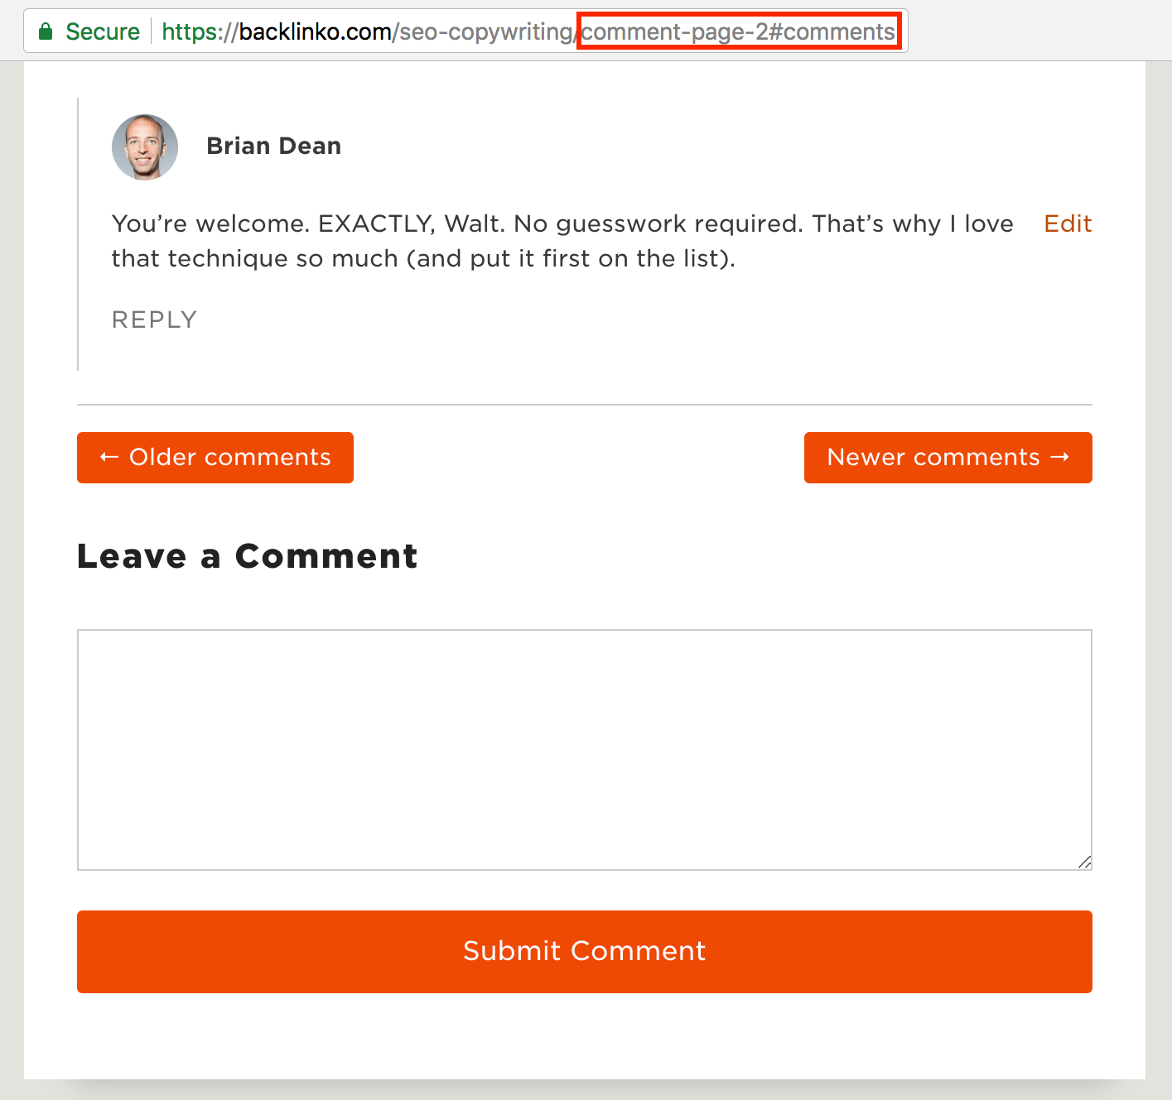

And I don’t want Google to index every single comment page. So we throw a noindex tag on those pages.

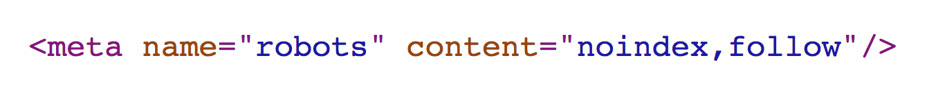

In this case, the pages that are blocked are meant to be blocked.

## **Step #6: Check Your Organic Traffic**

Now it’s time to see how much organic traffic you’re getting.

To do that, head over to [Google Analytics](https://www.google.com/analytics/" \o "Google Analytics" \t "https://backlinko.com/_blank).

## **Step #7: Improve Your On-Page SEO**

If you’re REALLY pressed for time and don’t have time to implement everything from the video, focus on these 5 strategies:

* Include your keyword in your title tag
* Include your keyword in first 100 words
* Add 5+ external links
* Add 5+ [internal links](https://backlinko.com/hub/seo/internal-links" \t "https://backlinko.com/_blank)
* Use [LSI keywords](https://backlinko.com/hub/seo/lsi" \t "https://backlinko.com/_blank)

## **Step #8: Set Up Keyword Rank Tracking**

Now it’s time to start tracking your rankings in the SERPs.

There are a million rank tracking tools out there.

But to me, the best out there is probably [SEMrush](https://backlinko.com/hub/seo/semrush" \o "SEMrush" \t "https://backlinko.com/_blank).

What’s cool about SEMrush is that ****it automatically finds keywords that you rank for****.

## **Step #9: Analyze Your Backlinks**

There’s no doubt about it:

[Backlinks](https://backlinko.com/backlinks-guide" \o "Backlinks Guide" \t "https://backlinko.com/_blank) are still REALLY important.

In fact, [our study of 1 million search results](https://backlinko.com/search-engine-ranking" \o "Search Engine Ranking" \t "https://backlinko.com/_blank) found that backlinks correlate with rankings ****more than any other factor****.

(I’m using [Ahrefs](https://backlinko.com/hub/seo/ahrefs" \o "Ahrefs" \t "https://backlinko.com/_blank) for this step. But you can also use [Majestic SEO](https://majestic.com/" \o "Majestic SEO" \t "https://backlinko.com/_blank) or [Moz Pro](https://backlinko.com/hub/seo/moz-pro" \o "Moz Pro" \t "https://backlinko.com/_blank))

## **Step #10: Fix Broken Links**

A few years back [Google stated](https://www.seroundtable.com/google-broken-links-19201.html" \o "Google stated" \t "https://backlinko.com/_blank) that they don’t “lose sleep” over broken links.

Broken links are bad for user experience… which CAN hurt your SEO.

****First, find broken pages on your site that Google can’t index.****

You can find this info in the Google Search Console’s “[Index Report](https://support.google.com/webmasters/answer/7440203?hl=en" \o "Index Report" \t "https://backlinko.com/_blank)”.

Sometimes you deleted pages for a reason (for example: you deleted a bunch of Zombie Pages).

You can find broken links through free tool like [Broken Link Check](http://www.brokenlinkcheck.com/" \o "Broken Link Check" \t "https://backlinko.com/_blank).

## **Step #11: Competitor Analysis**

Now it’s time to spy on your competitors.

Here’s how to do it:

****First, find your competitors’ best keywords.****

You can easily find this info using SEMrush

If your competitors rank for these keywords, you have a good chance to rank for them too.

Which makes them GREAT keywords to target.

****Second, check out the pages that are ranking for those terms.****

Then, figure out what those pages have in common. That way, you know what type of content works best in your niche.

## **Step #12: Make Your Content 10x Better**

Now it’s time to make the content on those pages 10x better.

Why?

It’s simple:

To rank in 2020, ****your content needs to kick butt****.